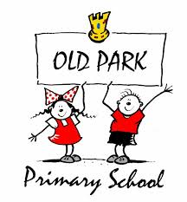
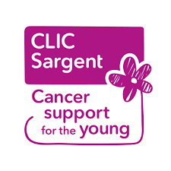
Dance-a-Thon Sponsor Form
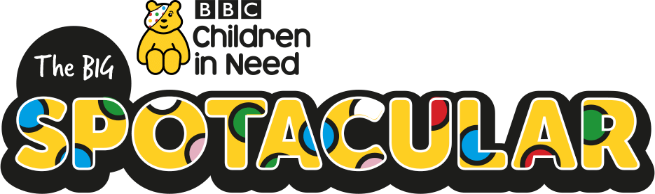

Your child will be taking part in the school’s annual Dance-a-Thon. This year, we will be dancing to disco classics!

Your child will dance for a set amount of time with the rest of their year group. In total, the school will dance for 8 hours to raise money for Clic Sargent, a charity very close to our hearts. The date of the dance-a-thon is Friday 17th November.

All children will be asked to contribute 50p on the day – this will be the school’s contribution to Children in Need. As the theme for this year’s Children in Need is ‘Spotacular’, the fancy dress theme will be ‘dress spotty’.

We have raised over £25,000 for Clic Sargent and would like this year to add even more to this total. Any sponsorships or donations are truly appreciated. There are several prizes and treats available for best effort, best dressed and for outstanding contributions to the day!

Updates on the event will be posted on our Facebook page and school website.

Thank you and KEEP DANCING!!!

Mrs Pearce & Mrs Johnson

Name of Child:
Class:
House Team:

Name | Amount | Name | Amount
For extra copies of the sponsor form, please visit our school website www.oldpark.primary.com

